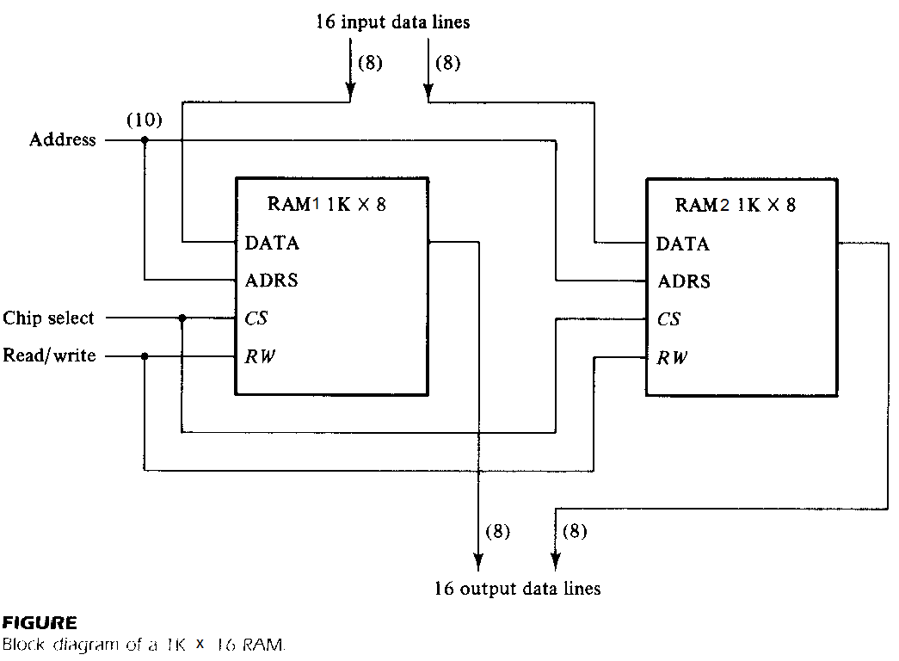

Figure above shows the interconnection of two 1Kx8 RAM chips to form a 1Kx16 memory. The 16 input and output data lines are split between the two chips. Both receive the same 10-bit address and the common CS and RW control inputs.

**module Memory_1Kx16 (addr, CS, RW, idata, odata);**

**input CS, RW;**

**input [9:0] addr;**

**input [15:0] idata;**

**output [15:0] odata;**

**RAM1 rc1 (addr, CS, RW, idata [15:8], odata [15:8]);**

**RAM2 rc2 (addr, CS, RW, idata [7:0], odata [7:0]);**

**endmodule**

**module RAM1 (addr, CS, RW, idata, odata);**

**input CS, RW;**

**input [9:0] addr;**

**input [7:0] idata;**

**output [7:0] odata;**

**reg [7:0] d_out;**

**reg [7:0] Mem1 [0:1023];**

**assign odata = (CS && RW)?d_out:8'bz;**

**always @(addr or idata or CS or RW)**

**if (CS && !RW)**

**Mem1 [addr] = idata;**

**always @(addr or CS or RW)**

**if (CS && RW)**

**d_out = Mem1 [addr];**

**initial**

**$readmemh ("memory1.dat", Mem1);**

**endmodule**

**//memory1.dat. This must be in the same directory as design and testbench. Otherwise you will need to specify the complete path.**

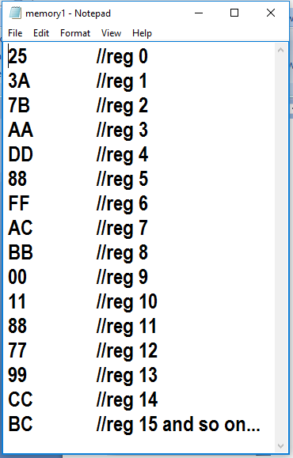

**module RAM2 (addr, CS, RW, idata, odata);**

**input CS, RW;**

**input [9:0] addr;**

**input [7:0] idata;**

**output [7:0] odata;**

**reg [7:0] d_out;**

**reg [7:0] Mem2 [0:1023];**

**assign odata = (CS && RW)?d_out:8'bz;**

**always @(addr or idata or CS or RW)**

**if (CS && !RW)**

**Mem2 [addr] = idata;**

**always @(addr or CS or RW)**

**if (CS && RW)**

**d_out = Mem2 [addr];**

**initial**

**$readmemh ("memory2.dat", Mem2);**

**endmodule**

**//memory2.dat. This must be in the same directory as design and testbench. Otherwise you will need to specify the complete path.**

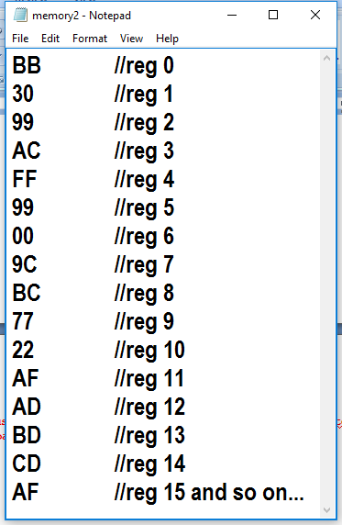

**module tst_Memory_1Kx16 ();**

**reg [9:0] address;**

**reg CE, RW;**

**reg [15:0] data_in;**

**wire [15:0] data_out;**

**Memory_1Kx16 m1 (**

**.addr(address),**

**.CS (CE),**

**.RW(RW),**

**.idata(data_in),**

**.odata(data_out));**

**initial begin**

**$display("Reading from Memory (already initialized/populated using $readmemh)...");**

**CE = 0;**

**RW = 0;**

**#5 address = 15;**

**#5 RW = 1;**

**#5 CE = 1;**

**#10 address = 1;**

**#10 address = 2;**

**#10 address = 3;**

**#10 address = 7;**

**#10 address = 6;**

**#10 address = 5;**

**#10 address = 4;**

**#10 address = 8;**

**#10 address = 9;**

**#10 address = 10;**

**#10 address = 11;**

**#10 address = 0;**

**#10 address = 14;**

**#10 address = 13;**

**#10 address = 12;**

**#500 $finish;**

**end**

**endmodule**

